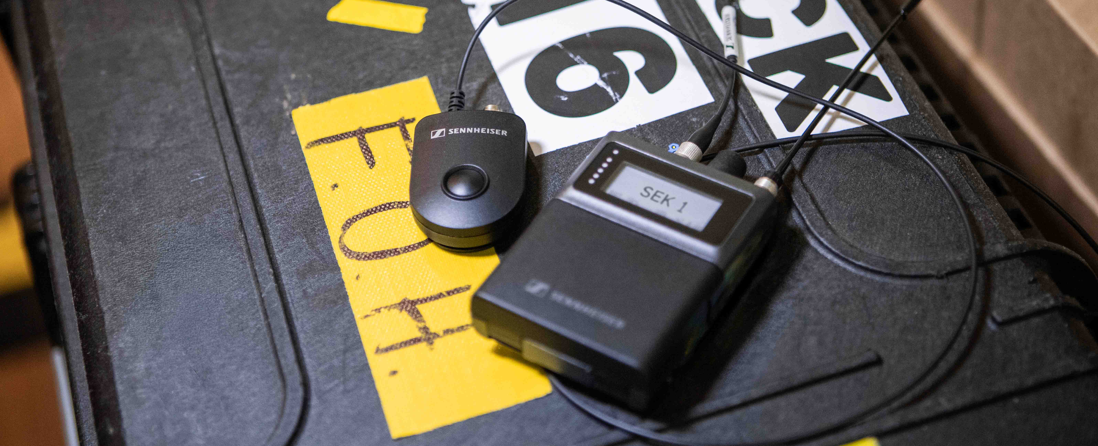

Latest Spectera firmware update adds Command functionality
SoundBase app now allows full system control, and Spectera certification has significantly progressed

Wedemark, 15 July 2026 — Sennheiser continues to expand the Spectera ecosystem with the introduction of a Command Button and firmware version 1.4. Together, these updates enable functions such as push-to-talk and push-to-mute, supporting typical workflows in live audio, broadcasting and places of worship. The new firmware version, available now, also introduces extended live monitoring capabilities via the Spectera WebUI. In addition, Sennheiser announced that Spectera can now be fully controlled via the brand-agnostic SoundBase app, and that Spectera has been rolled out almost globally.

Full software control via SoundBase app
“We’re delighted that SoundBase has fully integrated Spectera into its brand-agnostic RF planning and managing application,” says Dennis Stegemerten, Manager Software & Services at Sennheiser. “With Spectera WebUI for on-device control, and SoundBase for multiple Base Stations or mixed wireless setups, users have outstanding software tools for Spectera at their fingertips.”

Full Spectera integration makes SoundBase the world’s first RF management application built for both narrowband and wideband systems across multiple manufacturers – with full monitoring and control. Via the free SoundBase SE version, users can fully handle their large Spectera set-ups. If operators manage deployments with multiple brands, SoundBase recommends the PRO version of its app.

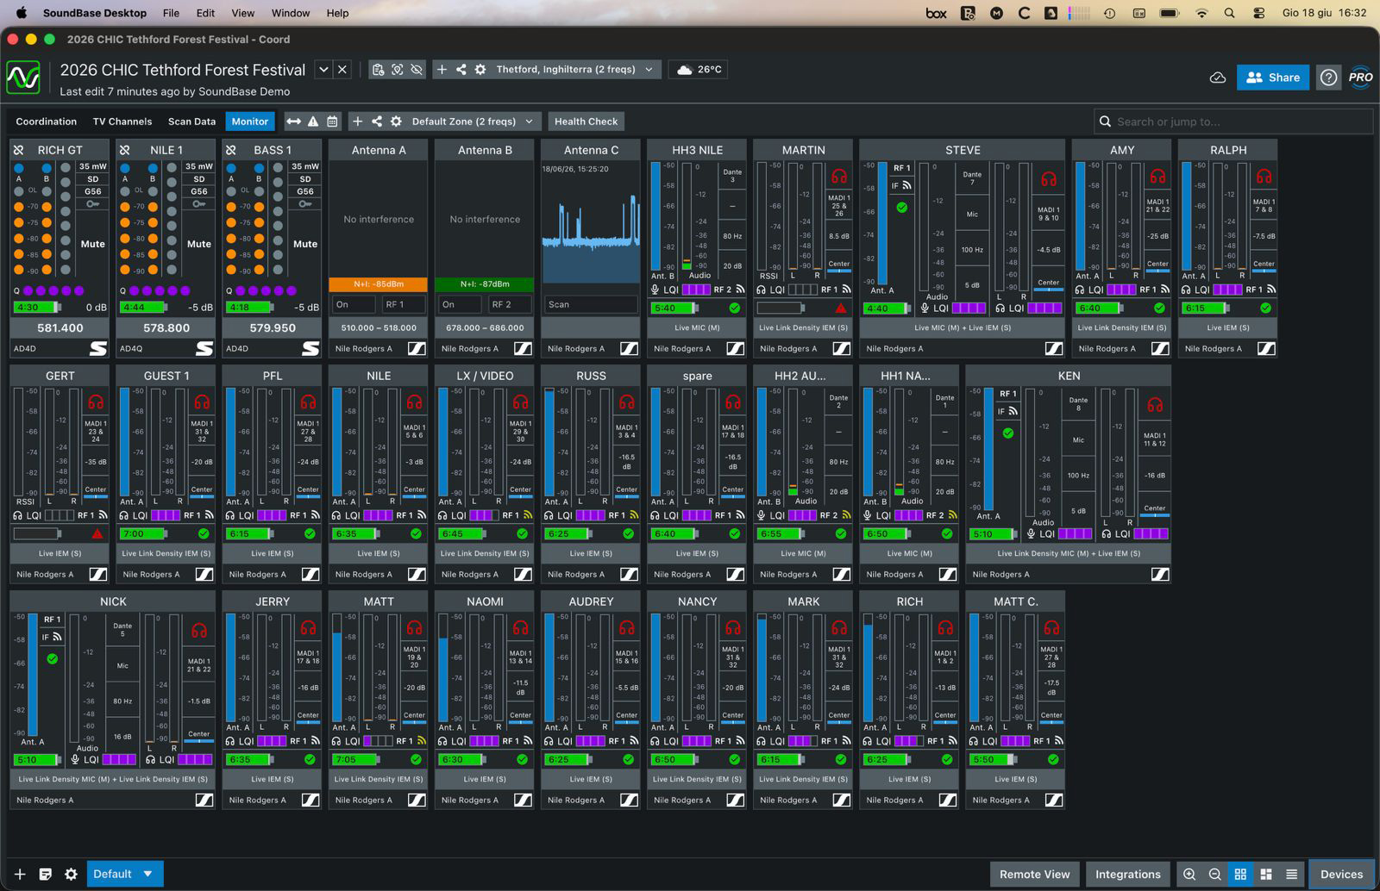
SoundBase have fully integrated Spectera into their RF management app. The pictured pro version of the app allows to control wideband systems alongside narrowband systems from multiple manufacturers

Spectera certified almost globally
Andreas Wilzeck, Sennheiser’s head of Spectrum Policy and Standards, looks back at years of regulatory work with satisfaction: “We’re very pleased that the only countries with open regulatory actions are Mainland China, South Korea and Japan. Many countries follow an ‘innovation first, regulation follows’ approach, and have directly certified Spectera without changing the regulation.”

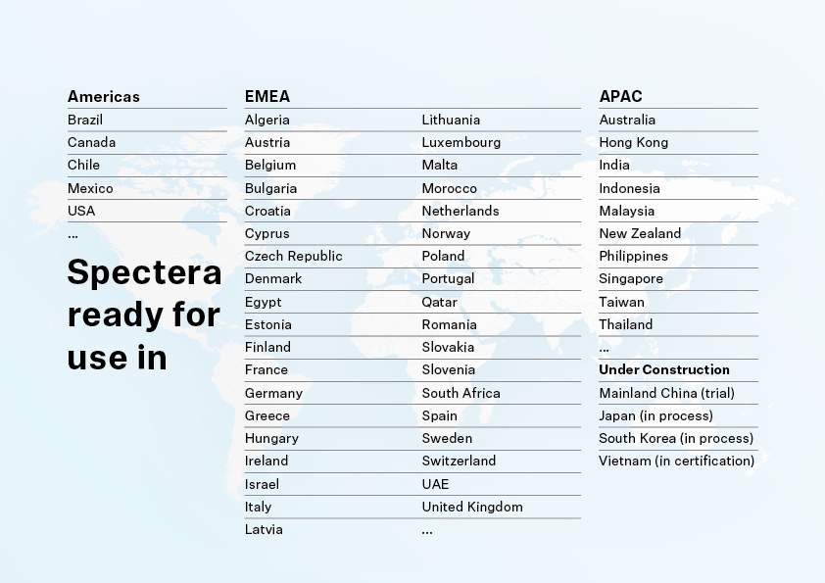
New monitoring and control capabilities for Spectera
Firmware version 1.4 introduces enhanced monitoring capabilities via the Spectera WebUI. Operators can monitor received signal strength (RSSI), link quality (LQI), battery levels, and interference status, as well as audio levels for mics and IEMs (peak and rms).

The update also introduces command functionality for Spectera, allowing operators to programme the audio outs of the Base Station and the Spectera Command Button, tailoring the system to their production requirements.

Spectera Command Button
The Spectera Command Button gives the artist or speaker direct control of the audio routing pre-configured in the wireless system. Connected between the SEK bodypack and the microphone, it enables end users to mute their audio, or open a talkback channel, i.e. a second communication channel that is not heard by the audience. To best fit workflow and preferences, the Spectera system allows the button to be configured as a latched or a momentary switch. An integrated clip allows for flexible positioning of the Command Button on clothing.

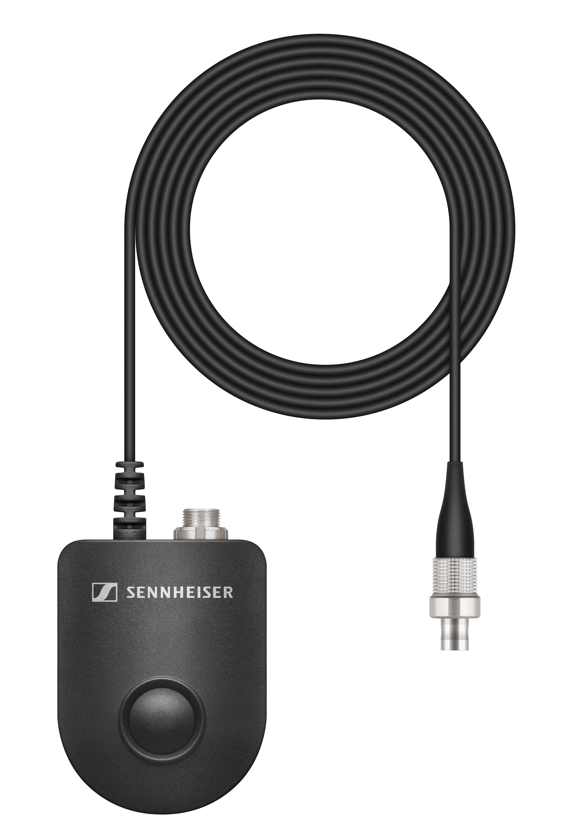 | The Spectera Command Button connects between the SEK and the microphone. In the Spectera software, it can be configured to trigger mute or talkback functions, and as a latched or momentary switch

“The mute function is typically used as a cough button, or when an artist or speaker is offstage. In a places of worship setting, it is ideal when others read or speak, or if any worship preparations should be unheard by the congregation,” explains Bernd Neubauer, Product Manager Professional Audio at Sennheiser. “The talkback function, on the other hand, allows broadcast hosts and interviewers to check back with production, or performers to speak directly with engineers and crew, without the audience hearing.”
The Spectera Command Button is also compatible with Sennheiser’s digital narrowband SK 9000 and SK 6000 bodypack transmitters, where the firmware supports mute and talkback functionality.

The Spectera firmware version 1.4 is now available for download here in the Download section of the Base Station product page. The Command Button is available to order now (Cat. No. 701014).

Spectera Training Series on YouTube
For those who want to learn more about Spectera and Sennheiser WMAS, the Sennheiser SoundAcademy has published a Spectera Training Series on YouTube. It takes users from an introduction to bidirectional wideband technology to Spectera system set-up and configuration, and also takes a look at WMAS implementations available today.

(Ends)

The images accompanying this media release can be downloaded here.

About the Sennheiser Brand – More than 80 Years of Building the Future of Audio
We live and breathe audio. We are driven by the passion to create audio solutions that make a difference. This passion has taken us from the world’s greatest stages to the quietest listening rooms – and made Sennheiser the name behind audio that doesn’t just sound good: It feels true. Since 1945, we have stood for building the future of audio and bringing remarkable sound experiences to our customers. While professional audio solutions such as microphones, meeting solutions, streaming technologies and monitoring systems are part of the business of Sennheiser electronic SE & Co. KG, the business with consumer devices such as headphones, soundbars and speech-enhanced hearables is operated by Sonova Holding AG under the license of Sennheiser.
www.sennheiser.com
www.sennheiser-hearing.com

Global press contact
Jacqueline Gusmag
+49 (0) 5130 600 – 1540
jacqueline.gusmag@sennheiser.com

